REST Assured ?
Rest Assuired is a open-source Java library that provides a domain-specific language (DSL) for writing automated tests against RESTful HTTP APIs.

Core Concept
REST Assured lets you express an API test as a human-readable sentence: "Given these headers and parameters, When I send a GET to /users, Then the status should be 200 and the body should contain 'John'." This mirrors how you'd describe a test in plain English.

Key capabilities at a glance
- Send HTTP requests (GET, POST, PUT, PATCH, DELETE, OPTIONS, HEAD)
- Set headers, query params, path params, cookies, and request bodies
- Validate response status code, headers, body content using Hamcrest matchers
- Extract values from JSON and XML using JsonPath and GPath
- Validate JSON and XML schema compliance
- Handle authentication (Basic, OAuth 2.0, Bearer, Digest)
- Supports multipart form data and file uploads
- Built-in request/response logging
- Integrates seamlessly with TestNG and JUnit

Why Maven for REST Assured?

REST Assured has several transitive dependencies (Jackson for serialization, Apache HttpClient for networking, Hamcrest for assertions, Groovy for JsonPath/GPath). Managing these by hand would mean downloading and tracking 10+ JAR files. Maven resolves them all automatically from the Maven Central repository.

Dependency | GroupId : ArtifactId | Purpose | Scope
REST Assured Core | io.rest-assured:rest-assured | The main library. Provides given/when/then DSL, request building, response validation. | test
JSON Schema Validator | io.rest-assured:json-schema-validator | Validates responses against a JSON Schema file. Essential for schema-level assertions. | test
TestNG | org.testng:testng | Test framework that manages @Test methods, @BeforeMethod hooks, data providers, parallel execution. | test
Jackson Databind | com.fasterxml.jackson.core:jackson-databind | Serializes Java objects to JSON (for request bodies) and deserializes JSON to POJOs (from responses). | test

The BDD-Style API: given / when / then

The Core Pattern
Every REST Assured test follows three phases:
Given — set up the request (headers, params, body, auth)
When — perform the HTTP action (GET, POST, etc.)
Then — assert on the response (status, headers, body)

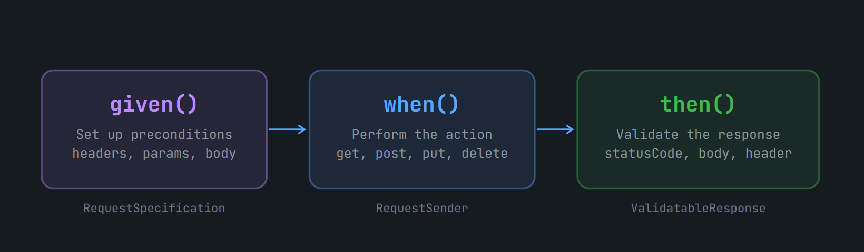

given()
static method of Rest Assured class that return a Request Specification object – a builder that collects all the information about your request before sending it.
It is Optional (if we have no preconditions to set (no headers, no params, no body))
it’s best practice to include it for better readability.

RequestSpecification spec = given()
// Headers
.header("Accept", "application/json")
.header("X-Custom-Header", "value")
.contentType(ContentType.JSON) // shorthand for Content-Type header

// Query parameters (?page=1&size=10)
.queryParam("page", 1)
.queryParam("size", 10)

// Path parameters (/users/{id})
.pathParam("id", 42)

// Request body (Phase 3 topic — shown for context)
.body("{\"name\":\"John\"}")

// Authentication (Phase 5 topic — shown for context)
.auth().basic("username", "password")

// Logging (covered in this phase)
.log().all(); // logs the entire request

given() returns a RequestSpecification. Every method you chain on it (like .header(), .queryParam()) also returns the same RequestSpecification

when() – action trigger

when() is a transition method.
It returns a RequestSender (also a RequestSpecification internally) and signals that you're done configuring and are about to send the request.

Method | Usage | HTTP Verb | Common use
.get(String path) | .when().get("/users") | GET | Fetch resource(s)
.post(String path) | .when().post("/users") | POST | Create resource
.put(String path) | .when().put("/users/1") | PUT | Full update
.patch(String path) | .when().patch("/users/1") | PATCH | Partial update
.delete(String path) | .when().delete("/users/1") | DELETE | Delete resource
.head(String path) | .when().head("/users") | HEAD | Check headers only
.options(String path) | .when().options("/users") | OPTIONS | Check allowed methods

/ Pattern 1: path appended to baseURI
.when().get("/api/users") // → GET https://reqres.in/api/users

// Pattern 2: full absolute URL (overrides baseURI)
.when().get("https://other.api.com/data")

// Pattern 3: with path param substitution
// Requires .pathParam("id", 2) in given()
.when().get("/api/users/{id}") // → GET /api/users/2

// Pattern 4: no path (uses only baseURI)
.when().get()

then() – validates response
then() receives the HTTP response and returns a ValidatableResponse object.
ValidatableResponse provides access to Hamcrest matchers, JsonPath, header checks, and schema validators.

.then()
// Status code
.statusCode(200)

// Response time (ms)
.time(Matchers.lessThan(2000L))

// Headers
.header("Content-Type", containsString("application/json"))

// Body assertions with JsonPath
.body("data.id", equalTo(2))
.body("data.first_name", equalTo("Janet"))
.body("data", notNullValue())

// Response logging on failure
.log().ifValidationFails();

extract() — getting values out (for later use)
After then(), you can switch from validation to extraction using .extract(). This returns a ExtractableResponse
String userId =
given()
.contentType(ContentType.JSON)
.when()
.get("/api/users/2")
.then()
.statusCode(200)
.extract()
.path("data.id"); // pulls "id" from JSON

System.out.println("User ID: " + userId); // → User ID: 2

/*
* Full given().when().then() chain — anatomy breakdown
*
* given() → returns RequestSpecification (builder)
* when() → returns RequestSender (trigger)
* get() → returns Response (raw HTTP response)
* then() → returns ValidatableResponse (assertion wrapper)
*/

given() // ← entry point
.baseUri("https://reqres.in") // ← optional inline baseURI
.header("Accept", "application/json")
.queryParam("page", 2)
.log().all() // ← log full request before sending

.when() // ← transition: done configuring
.get("/api/users") // ← FIRE! sends GET, returns Response

.then() // ← wrap Response as ValidatableResponse
.log().ifValidationFails() // ← log response only when a check fails
.statusCode(200) // ← assert HTTP 200 OK
.body("page", equalTo(2)) // ← JSON field "page" == 2
.body("data", not(empty())); // ← "data" array is not empty

